USE procurement_intelligence;

-- Question 1: Provincial Opportunity Ranking

WITH provincial_summary AS (
SELECT
m.tender_province AS province,
COUNT(DISTINCT m.ocid) AS tender_count,
COUNT(c.id) AS contracts_awarded,
SUM(c.value_amount) AS total_value,
AVG(c.value_amount) AS avg_value
FROM main_staging m
INNER JOIN contracts_staging c
ON m.ocid = c.main_ocid
WHERE c.value_amount > 0
AND m.tender_province IS NOT NULL
GROUP BY m.tender_province
)
SELECT
province,
tender_count,
contracts_awarded,
ROUND(total_value / 1000000000, 3) AS total_value_billions,
ROUND(avg_value / 1000000, 2) AS avg_contract_millions,
ROUND(total_value * 100.0 / SUM(total_value) OVER (), 2) AS pct_of_national_spend,

RANK() OVER (ORDER BY total_value DESC) AS value_rank,
RANK() OVER (ORDER BY tender_count DESC) AS volume_rank,

-- Safe subtraction using CAST AS SIGNED
CAST(RANK() OVER (ORDER BY tender_count DESC) AS SIGNED)
-
CAST(RANK() OVER (ORDER BY total_value DESC) AS SIGNED) AS rank_gap

FROM provincial_summary
ORDER BY total_value DESC;

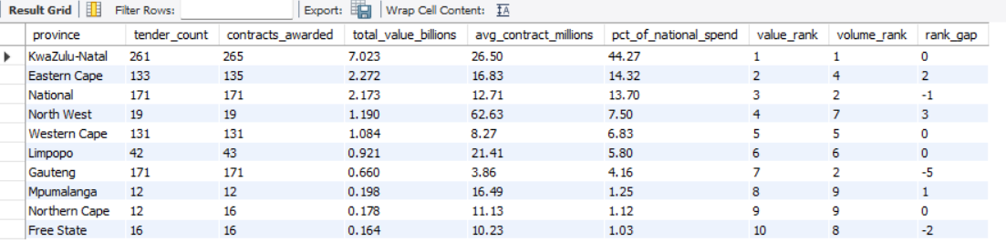

-- Question 2: Monthly & Quarterly Timing Intelligence

SELECT
QUARTER(m.date) AS quarter,
MONTHNAME(m.date) AS month_name,
MONTH(m.date) AS month_num,
COUNT(DISTINCT m.ocid) AS tenders_issued,
COUNT(c.id) AS contracts_awarded,
ROUND(SUM(c.value_amount) / 1e6, 2) AS total_value_millions,
ROUND(AVG(c.value_amount) / 1e6, 2) AS avg_contract_millions,
ROUND(COUNT(DISTINCT m.ocid) * 100.0 /
SUM(COUNT(DISTINCT m.ocid)) OVER (), 2) AS pct_of_annual_volume,
CASE
WHEN COUNT(DISTINCT m.ocid) >= AVG(COUNT(DISTINCT m.ocid)) OVER () * 1.2 THEN 'Peak — Full bid capacity'
WHEN COUNT(DISTINCT m.ocid) <= AVG(COUNT(DISTINCT m.ocid)) OVER () * 0.6 THEN 'Dead zone — Pipeline prep'
ELSE 'Active — Normal operations'
END AS bid_team_recommendation
FROM main_staging m
LEFT JOIN contracts_staging c ON m.ocid = c.main_ocid
WHERE m.date IS NOT NULL
GROUP BY QUARTER(m.date), MONTHNAME(m.date), MONTH(m.date)
ORDER BY month_num;

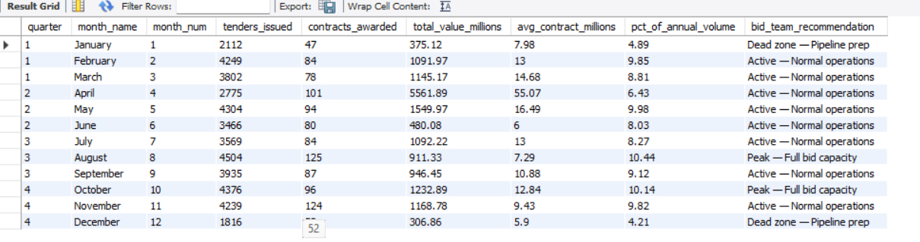

-- Question 3: Sector × Province × Quarter Matrix (Top 20)

SELECT
m.tender_mainprocurementcategory AS sector,
m.tender_province AS province,
QUARTER(m.date) AS quarter,
COUNT(c.id) AS contract_count,
ROUND(AVG(c.value_amount) / 1e6, 2) AS avg_value_millions,
ROUND(SUM(c.value_amount) / 1e6, 2) AS total_value_millions,
ROUND(MAX(c.value_amount) / 1e6, 2) AS max_contract_millions,
CASE
WHEN COUNT(c.id) >= 5 THEN 'Reliable'
WHEN COUNT(c.id) >= 2 THEN 'Caution'
ELSE 'Insufficient Data'
END AS reliability_tier,
CASE
WHEN COUNT(c.id) >= 5 THEN ROUND(AVG(c.value_amount) / 1e6, 2)
WHEN COUNT(c.id) >= 2 THEN ROUND(AVG(c.value_amount) / 1e6 * 0.5, 2)
ELSE 0
END AS weighted_opportunity_score
FROM main_staging m
INNER JOIN contracts_staging c ON m.ocid = c.main_ocid
WHERE c.value_amount > 0
AND m.tender_province IS NOT NULL
AND m.tender_mainprocurementcategory IS NOT NULL
AND m.date IS NOT NULL
GROUP BY m.tender_mainprocurementcategory, m.tender_province, QUARTER(m.date)
HAVING reliability_tier != 'Insufficient Data'
ORDER BY weighted_opportunity_score DESC
LIMIT 20;

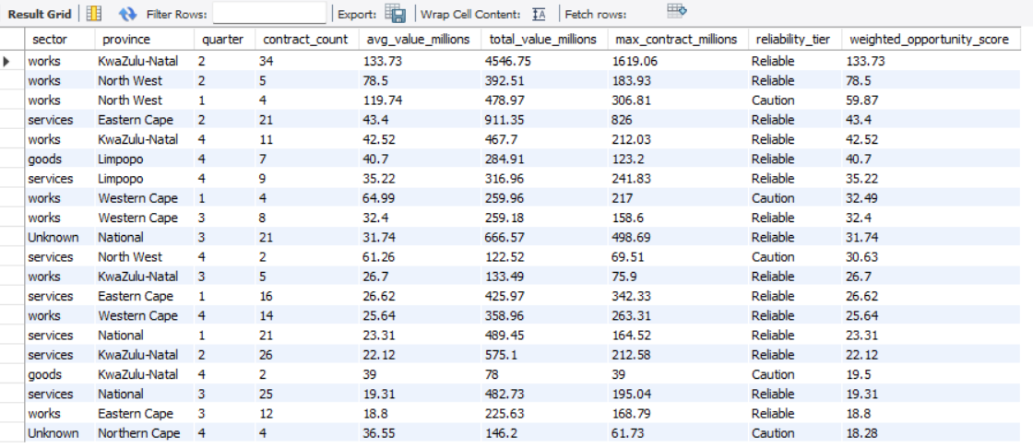

-- Question 4: Dominant Suppliers & Concentration

WITH supplier_totals AS (
SELECT
s.name AS supplier,
COUNT(DISTINCT a.id) AS total_awards,
ROUND(SUM(a.value_amount) / 1000000, 2) AS total_value_millions,
ROUND(AVG(a.value_amount) / 1000000, 2) AS avg_award_millions,
ROUND(MAX(a.value_amount) / 1000000, 2) AS largest_single_award
FROM awards_suppliers_staging s
INNER JOIN awards_staging a
ON s.awards_id = a.id
WHERE a.value_amount IS NOT NULL
AND a.value_amount > 0
GROUP BY s.name
),
ranked AS (
SELECT *,
RANK() OVER (ORDER BY total_value_millions DESC) AS spend_rank,
SUM(total_value_millions) OVER () AS grand_total
FROM supplier_totals
)
SELECT
spend_rank,
supplier,
total_awards,
total_value_millions,
avg_award_millions,
largest_single_award,
ROUND(total_value_millions * 100.0 / grand_total, 2) AS pct_of_total_spend,
ROUND(SUM(total_value_millions)
OVER (ORDER BY spend_rank) * 100.0 / grand_total, 2) AS cumulative_pct
FROM ranked
WHERE spend_rank <= 20
ORDER BY spend_rank;

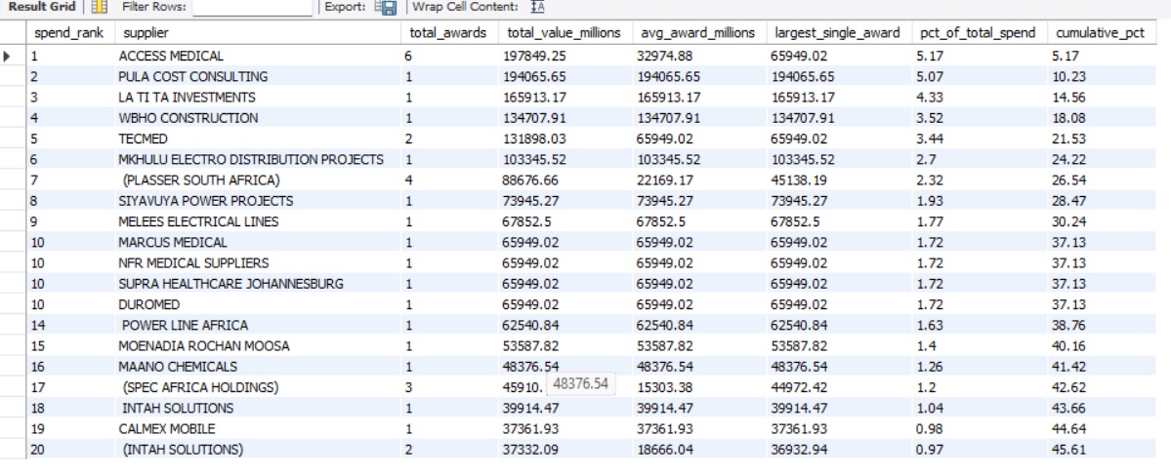

-- Question 5: Governance Red Flags / Anomaly Detection

SELECT
m.ocid,
m.buyer_name,
m.tender_province AS province,
m.tender_mainprocurementcategory AS sector,
m.tender_procurementmethod AS method,
s.name AS supplier,
ROUND(c.value_amount / 1e6, 2) AS contract_value_millions,
m.date AS tender_date,
CASE
WHEN m.tender_procurementmethod IN ('direct', 'limited', 'selective')
AND c.value_amount > 15000000
THEN 'FLAG 1 — Restricted method above R15M'
WHEN c.value_amount > 100000000
AND m.tender_procurementmethod != 'open'
THEN 'FLAG 2 — Non-open mega contract'
WHEN c.value_amount > 50000000
AND s.name IN (
SELECT name
FROM awards_suppliers_staging
GROUP BY name
HAVING COUNT(DISTINCT awards_id) = 1
)
THEN 'FLAG 3 — Single large award, no prior history'
WHEN c.value_amount > 200000000
THEN 'FLAG 4 — Mega contract above R200M'
ELSE 'Normal'
END AS anomaly_flag
FROM main_staging m
INNER JOIN contracts_staging c ON m.ocid = c.main_ocid
LEFT JOIN awards_staging a ON m.ocid = a.main_ocid
LEFT JOIN awards_suppliers_staging s ON a.id = s.awards_id
WHERE c.value_amount > 0
HAVING anomaly_flag != 'Normal'
ORDER BY contract_value_millions DESC;

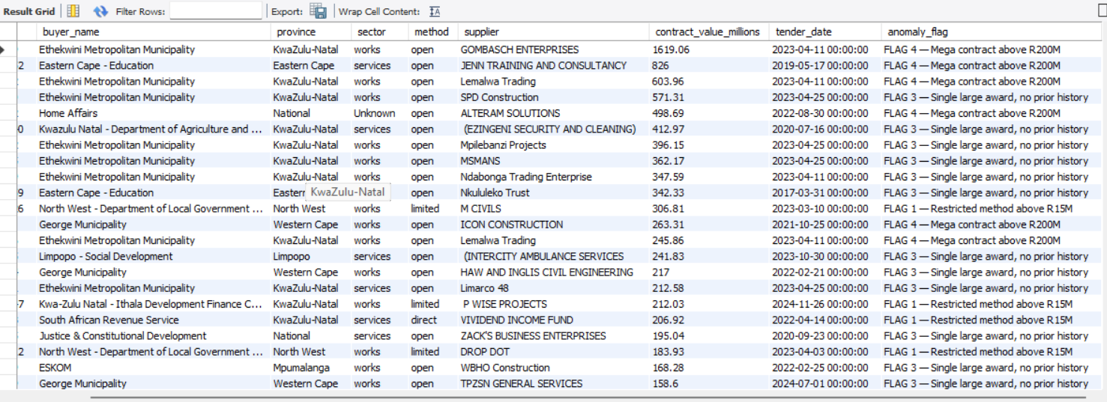

-- Question 6: Realistic Value Benchmarks by Sector + Province

SELECT
m.tender_mainprocurementcategory AS sector,
m.tender_province AS province,
COUNT(c.id) AS sample_size,
ROUND(AVG(c.value_amount) / 1000000, 2) AS mean_millions,
ROUND(MIN(c.value_amount) / 1000000, 2) AS min_millions,
ROUND(MAX(c.value_amount) / 1000000, 2) AS max_millions,
ROUND(STDDEV(c.value_amount) / 1000000, 2) AS std_dev_millions,
CASE
WHEN COUNT(c.id) >= 10 THEN 'High reliability'
WHEN COUNT(c.id) >= 5 THEN 'Medium reliability'
ELSE 'Low reliability'
END AS benchmark_reliability
FROM main_staging m
INNER JOIN contracts_staging c ON m.ocid = c.main_ocid
WHERE c.value_amount > 0
AND m.tender_mainprocurementcategory IS NOT NULL
AND m.tender_province IS NOT NULL
GROUP BY m.tender_mainprocurementcategory, m.tender_province
HAVING COUNT(c.id) >= 5
ORDER BY mean_millions DESC;

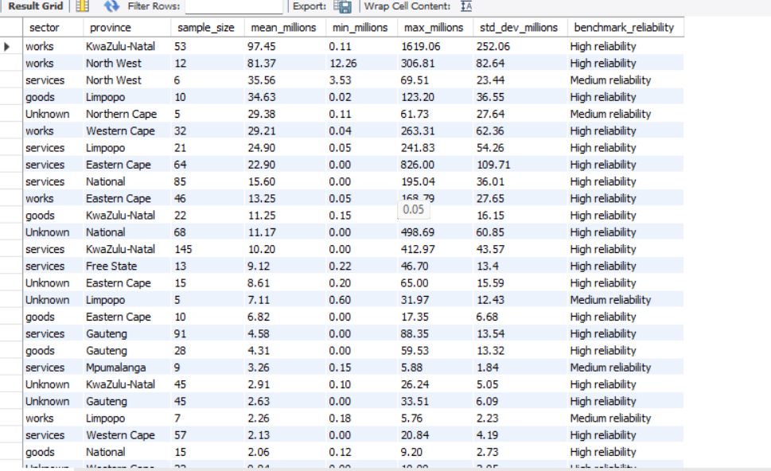

-- Question 7: Contract Duration Analysis

SELECT
m.tender_mainprocurementcategory AS sector,
CASE
WHEN c.period_durationindays <= 90 THEN 'Under 3 months'
WHEN c.period_durationindays <= 180 THEN '3-6 months'
WHEN c.period_durationindays <= 365 THEN '6-12 months'
WHEN c.period_durationindays <= 730 THEN '1-2 years'
WHEN c.period_durationindays <= 1095 THEN '2-3 years'
ELSE 'Over 3 years'
END AS duration_band,
COUNT(c.id) AS contract_count,
ROUND(AVG(c.value_amount) / 1e6, 2) AS avg_value_millions,
ROUND(AVG(c.period_durationindays), 0) AS avg_days,
ROUND(COUNT(c.id) * 100.0 / SUM(COUNT(c.id)) OVER (PARTITION BY m.tender_mainprocurementcategory), 2) AS pct_within_sector
FROM main_staging m
INNER JOIN contracts_staging c ON m.ocid = c.main_ocid
WHERE c.period_durationindays > 0
AND c.value_amount > 0
GROUP BY m.tender_mainprocurementcategory, duration_band
ORDER BY sector, duration_band;

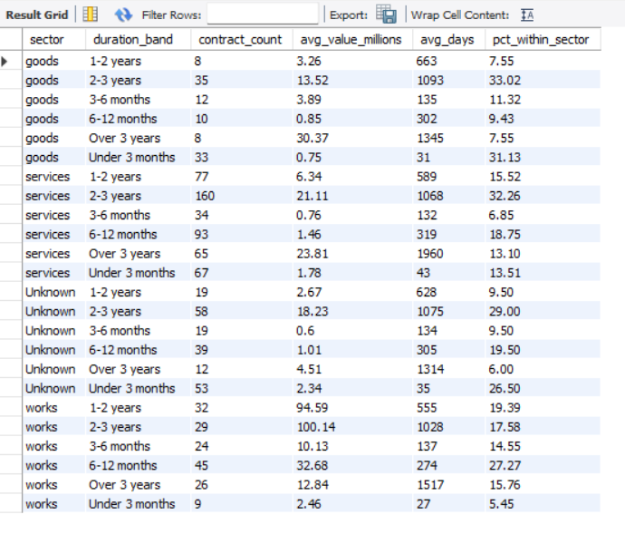

-- Question 8: Top Buyers Intelligence
SELECT
m.buyer_name,
m.tender_province AS province,
m.tender_mainprocurementcategory AS sector,
COUNT(DISTINCT m.ocid) AS tenders_issued,
COUNT(c.id) AS contracts_awarded,
ROUND(SUM(c.value_amount) / 1e6, 2) AS total_spend_millions,
ROUND(AVG(c.value_amount) / 1e6, 2) AS avg_contract_millions,
ROUND(COUNT(c.id) * 100.0 / NULLIF(COUNT(DISTINCT m.ocid), 0), 1) AS award_conversion_rate_pct,
CASE
WHEN AVG(c.value_amount) > 50000000 THEN 'Tier 1 — Strategic'
WHEN AVG(c.value_amount) > 10000000 THEN 'Tier 2 — High Value'
WHEN AVG(c.value_amount) > 1000000 THEN 'Tier 3 — Mid Market'
ELSE 'Tier 4 — Small'
END AS buyer_tier
FROM main_staging m
INNER JOIN contracts_staging c ON m.ocid = c.main_ocid
WHERE c.value_amount > 0
GROUP BY m.buyer_name, m.tender_province, m.tender_mainprocurementcategory
HAVING COUNT(c.id) >= 2
ORDER BY total_spend_millions DESC
LIMIT 25;

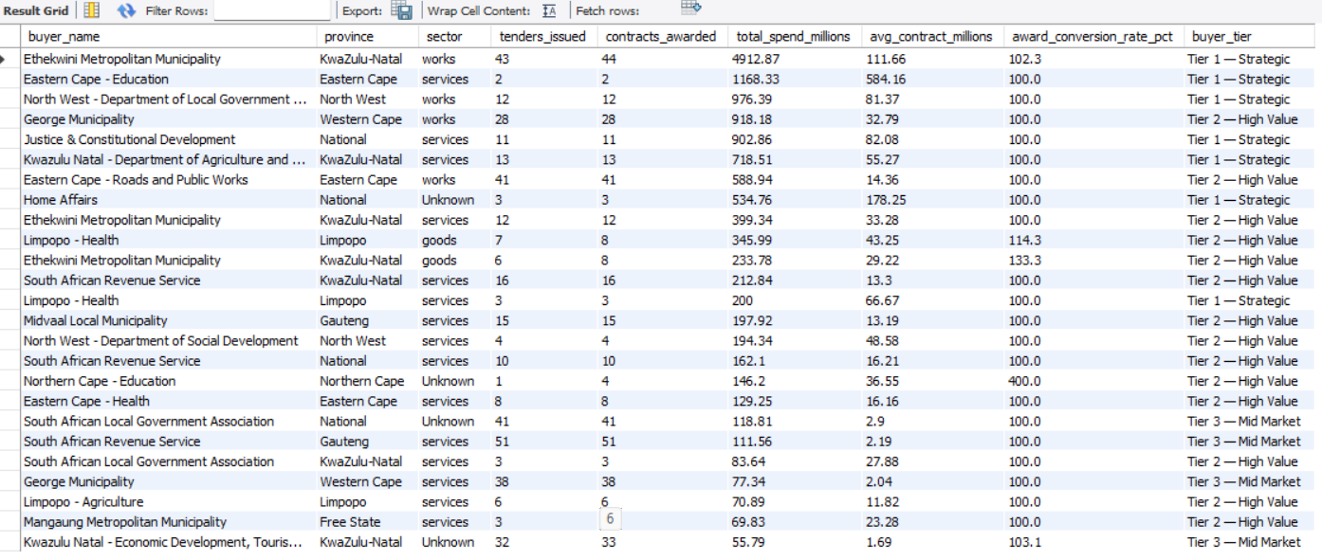

-- Question 9: Market Trends Over Time

SELECT
YEAR(m.date) AS year,
COUNT(DISTINCT m.ocid) AS total_tenders,
COUNT(c.id) AS contracts_awarded,
ROUND(SUM(c.value_amount) / 1e9, 3) AS total_value_billions,
ROUND(SUM(CASE WHEN m.tender_procurementmethod = 'open' THEN 1 ELSE 0 END) * 100.0 /
COUNT(DISTINCT m.ocid), 1) AS open_tender_pct,
ROUND(SUM(CASE WHEN m.tender_procurementmethod IN ('direct','limited','selective')
THEN 1 ELSE 0 END) * 100.0 / COUNT(DISTINCT m.ocid), 1) AS restricted_tender_pct
FROM main_staging m
LEFT JOIN contracts_staging c ON m.ocid = c.main_ocid AND c.value_amount > 0
WHERE m.date IS NOT NULL
AND YEAR(m.date) >= 2021
GROUP BY YEAR(m.date)
ORDER BY year;

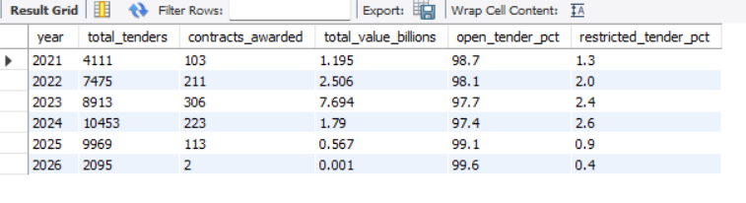

-- Question 10 : Top 10 Suppliers by Total Awarded Value

WITH supplier_summary AS (
SELECT
s.name AS supplier_name,
COUNT(DISTINCT a.id) AS total_awards,
ROUND(SUM(a.value_amount) / 1000000, 2) AS total_value_millions,
ROUND(AVG(a.value_amount) / 1000000, 2) AS avg_award_millions,
ROUND(MAX(a.value_amount) / 1000000, 2) AS largest_award_millions,
COUNT(DISTINCT m.tender_province) AS provinces_active,
COUNT(DISTINCT m.tender_mainprocurementcategory) AS sectors_active
FROM awards_suppliers_staging s
INNER JOIN awards_staging a ON s.awards_id = a.id
INNER JOIN main_staging m ON a.main_ocid = m.ocid
WHERE a.value_amount > 0
GROUP BY s.name
)
SELECT
RANK() OVER (ORDER BY total_value_millions DESC) AS `rank`,
supplier_name,
total_awards,
total_value_millions,
avg_award_millions,
largest_award_millions,
provinces_active,
sectors_active
FROM supplier_summary
ORDER BY total_value_millions DESC
LIMIT 10;

